GUEST OF THE MONTH
May 2025

Jason Rondou, Assistant General Manager of Power
Engineering, Planning, Major Projects, and New Business

UPDATE ON POWER SYSTEM ISSUES
Summary by Robert Yoshimura
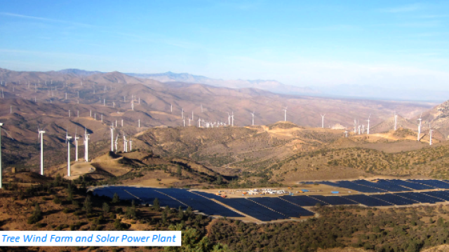
Jason Rondou was reassigned from his former position as Chief of Staff in the General Manager’s office to his current role amid the Palisades fire disaster in January. That move was made to sustain organizational focus on critical ongoing efforts associated with the LA 100 transition to clean energy by 2035, to sustain focus on system reliability, and forestall distractions that may result from disaster recovery efforts. A related focal point will be the major revamping of business processes in the new business area with the help of consultants and new management staff at the top of that organization. Such efforts are needed to accommodate the anticipated increase in new business resulting from the electrification of transportation and buildings and mitigation of homelessness.

LA 100. The Power System is contemplating more than 50 transmission improvements to accommodate increased demand and reliability including the conversion of the Victorville Transmission Line from AC to DC. They are also considering an undersea transmission line from the central coast and privately developed and funded projects by third parties. Another priority is to increase the geographical diversity of transmission lines to improve the resiliency of power supply in the face of disasters such as wildfires or earthquakes.

Distributed Resources. DWP has long been a leader in distributed resources and continues to use net metering which has been instrumental in incentivizing new solar. However, cost is becoming an issue and DWP is searching for ways to reduce that cost, which will require a rate case analysis. Nevertheless, additional new sources of cost-effective distributed energy including solar, battery storage, and demand response are being sought and a new contract for an expanded portfolio of demand response will go to the Board of Commissioners this summer.

A power rate case analysis is needed to determine the real cost to ratepayers of net metering. Then, rates must somehow be adjusted to be equitable to both those who have roof-top solar and those who do not. The current rate structure incentivizes power use at night which needs to be changed to encourage heavy power use such as electric vehicle charging to occur midday when surplus energy is available.

Renewable Energy. The Eland Battery plus Storage project in Mojave California is now operational and will provide a total of 400 MW of generation plus 300 MW of 4-hour battery storage capacity. Remarkably, DWP signed a power purchase contract for that capacity for $40/MWh which is roughly half of the price such power could be obtained today. The contract was signed pre-Covid before supply-chain problems and lithium shortages manifested higher costs. The contract was negotiated through the Southern California Public Power Authority and is valid for 25 years and has a buyout option. Other local utilities such as Glendale Water & Power also benefit from the project.

Because of its relatively small carbon footprint on a national and worldwide scale, DWP’s impact on climate change is best achieved by demonstrating a successful transition to renewable energy that maintains the reliability and affordability of electric power. Studies have shown that in-basin on-call generation is needed to maintain the reliability to which ratepayers are accustomed to. However, there are now some question as to the availability of $100 million of federal funding that was previously earmarked for the Scattergood hydrogen conversion project. Without the federal funding, DWP would bear additional costs and accept a higher risk.

A feedback loop is built into monthly reports to the Board of Commissioners and frequent presentations to the City Council regarding progress on the transition to clean and renewable energy. Thus, the concerns that W&PA has expressed about the viability and cost of achieving the transition by 2035 will become apparent as progress toward the goal is made and especially if timelines begin to slip.

The need for in-basin generation to sustain the reliability of a power system based on intermittent renewable sources is extremely important, but difficult to explain to the public. The Scattergood conversion to gas and hydrogen fuel has undergone extensive study more than any other project in DWP history and its need is unquestioned among DWP staff. Yet skeptics continue to question DWP’s motivation in spending large amounts of money on a fossil-fueled project. Furthermore, the conversion of Scattergood to 100% green hydrogen fuel cannot be guaranteed because the technology isn’t fully tested on a large scale, and the infrastructure for production and delivery of green hydrogen fuel does not yet exist. The challenge is to keep educating the Board, City Council, and other decision-makers who seem to understand the project's complexities so far.

Intermountain Power Project (IPP). IPP is a major component of the transition to renewable energy and will incorporate an abundance of new and innovative technology. Despite the challenges of that technology, the project is progressing on schedule. The electrolysis plant that will produce the green hydrogen fuel for the plant will be completed next year. Some Utah politicians have expressed interest in keeping the coal-fired portion of the plant in order to provide energy for AI data centers now expected to be built soon. DWP is amenable to that proposal as long as the state of Utah is willing to take responsibility for its operation. Other state leaders have requested a feasibility study for the construction of a nuclear power plant at the IPP site. That study is now ongoing.

